S3 – GROUP BY - AVG -SUM

# What you will know:

GROUP BY – AVG - SUM

# Instructions: Open [this online SQL editor](https://www.w3schools.com/sql/trysql.asp?filename=trysql_op_in)

**Exercise 1: Databases on W3school**

Each product of **Products** table has a **category ID** (*this ID refers to an element in the* ***Categories*** *table*)

## Q1 : Write a SQL query to display the **number of products per category**.

Expected columns:

CategoryID Number of items

**Your query:​​** SELECT CategoryID, COUNT(CategoryID) AS [Number of items] FROM Products GROUP BY CategoryID;

…………………………………………………………………………………………………………………………………………………………….

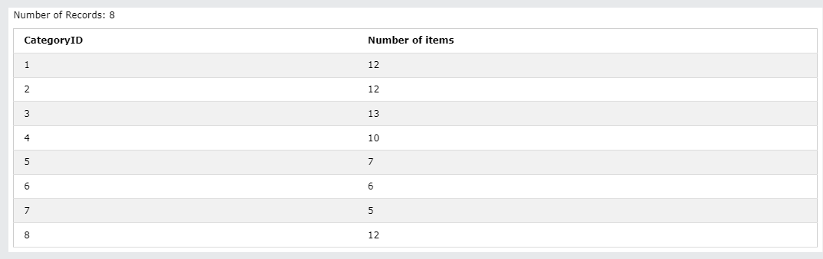

## Q2: Write a SQL query to display the **average price** of items per category ID.

Expected columns:

CategoryID Average items price

**Your query:**  **SELECT CategoryID, AVG(Price) AS [Average items price] FROM Products GROUP BY CategoryID;**

…………………………………………………………………………………………………………………………………………………………….

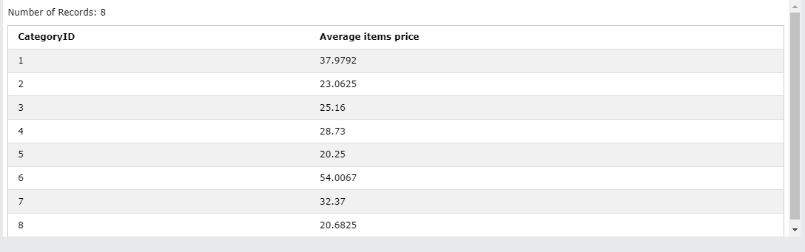

## Q3: Write a SQL query to display the **total of the price** of all items per category ID.

Expected columns:

Category ID Total items price

**Your query: SELECT CategoryID, SUM(Price) AS [Total items price] FROM Products GROUP BY CategoryID;**

…………………………………………………………………………………………………………………………………………………………….



**Exercise 2: World Table**

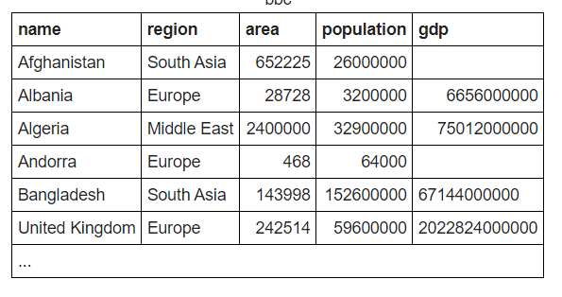

**Q1:** write a statement to sum of population of all countries.

**Your query: SELECT SUM(population) AS countries from statement GROUP BY population;**

**Q2** : write a statement to sum of population of all countries in «South Asia»

**Your query: SELECT SUM(population) AS countries WHERE population in (South Asia) from statement;**

**Q3:** write a statement to count GDP is null

**Your query: SELECT COUNT(gdp) COUNT statement;**

**Q4**: Write a statemet to showthe number of countries in each continent and group by continents:

**Your query: SELECT DISTINCT(name) AS continents FROM statement GROUP BY continents;**

**Q5** : write a statement to show the total population in each continent, group by continents :

**Your query: SELECT SUM(population) AS continents FROM statement GROUP BY continents;**

**Q6 :** For each relevant continent show the number of countries that has a population of at least 200000000.

**Your query:**

Top of Form